|  |
| --- |
| **Procedure to disable FLQ MO monitor PD errors.** |

**Equipment and Tools:**

* RS-232 cable, male/male, straight through, 9Pins
* Software 1377882.exe

**Setup:**

* Connect the RS-232 cable to the laser and computer

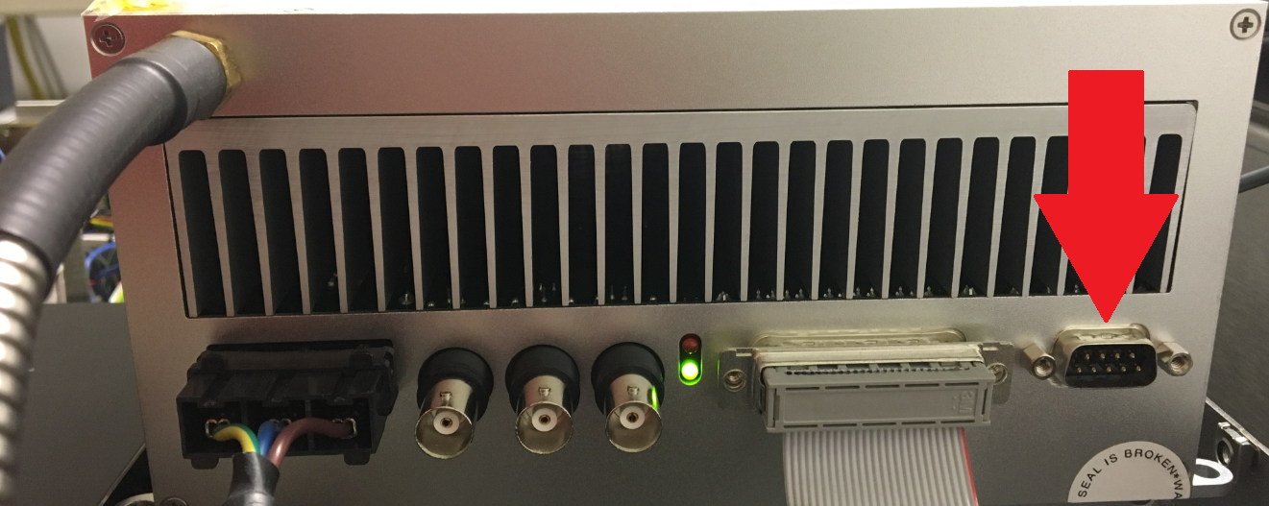

**Procedure:**

* Switch on the main switch of the fiber laser to receive 5V.

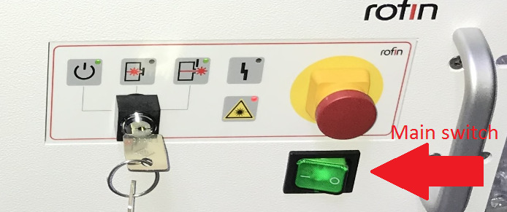

* Start the software 1377882.exe. This screen should appear:



* Select the comm port to which the laser is connected and press the “Connect” button. The program will now look like this:



* Press the “GO!” button.
* If the update completes successfully, the following message will appear:



* If the update does not complete correctly , this message will be shown:



* If the error message appears, check the connections and power to the laser and press the “GO!” button again. If the update does not complete the second time, please contact Coherent.
* Close the software by clicking the red box with the “X” in the upper right hand corner.
* Turn off the main switch of the laser.
* The process is now complete.